Experiment 8
TryHackMe Room: Nmap Live Host Discovery | https://tryhackme.com/room/nmap01
NMAP
Aim
To discover live hosts on a network using Nmap host-discovery scans — ARP scan, ICMP scan, and TCP/UDP ping scan — and to understand which protocol operates at which layer of the TCP/IP model, and when each one applies.
INTRODUCTION
Nmap can determine whether a host is alive using four different protocols, one at each relevant layer of
the TCP/IP stack:
• ARP (Link layer) — for hosts on the same local subnet
• ICMP (Network layer) — echo, timestamp, and address-mask requests
• TCP (Transport layer) — SYN and ACK ping probes
• UDP (Transport layer) — relies on an ICMP &quot;port unreachable&quot; reply
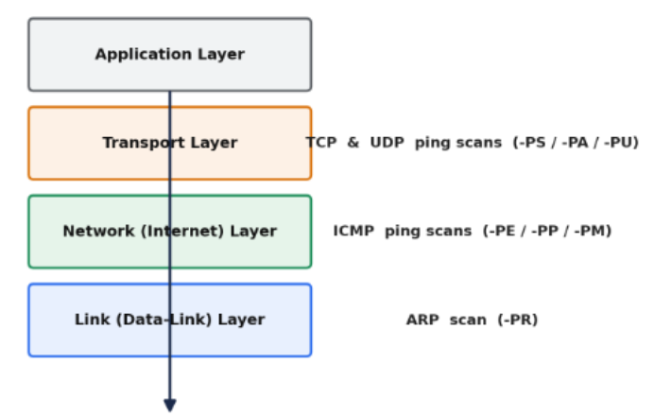
PROCEDURE:
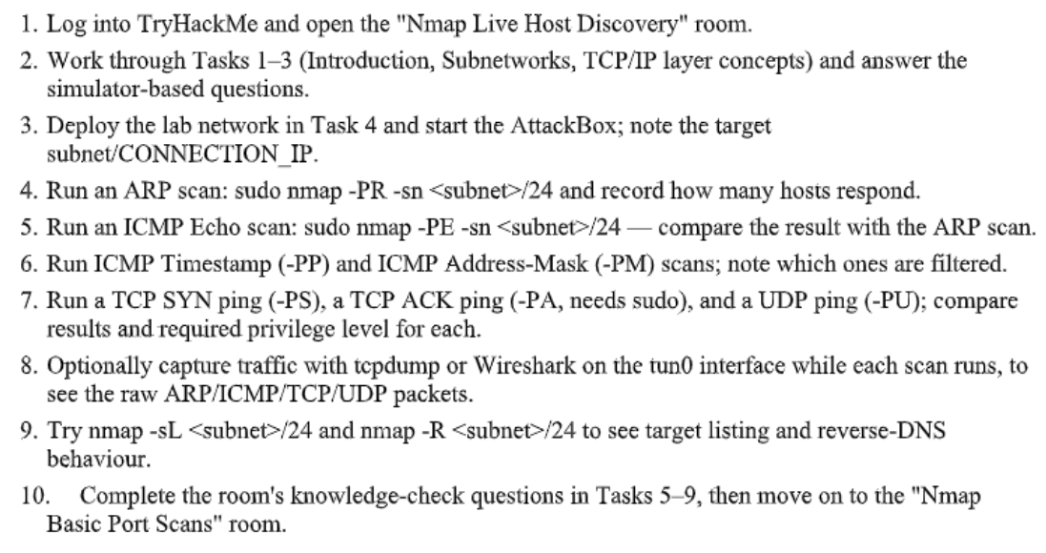
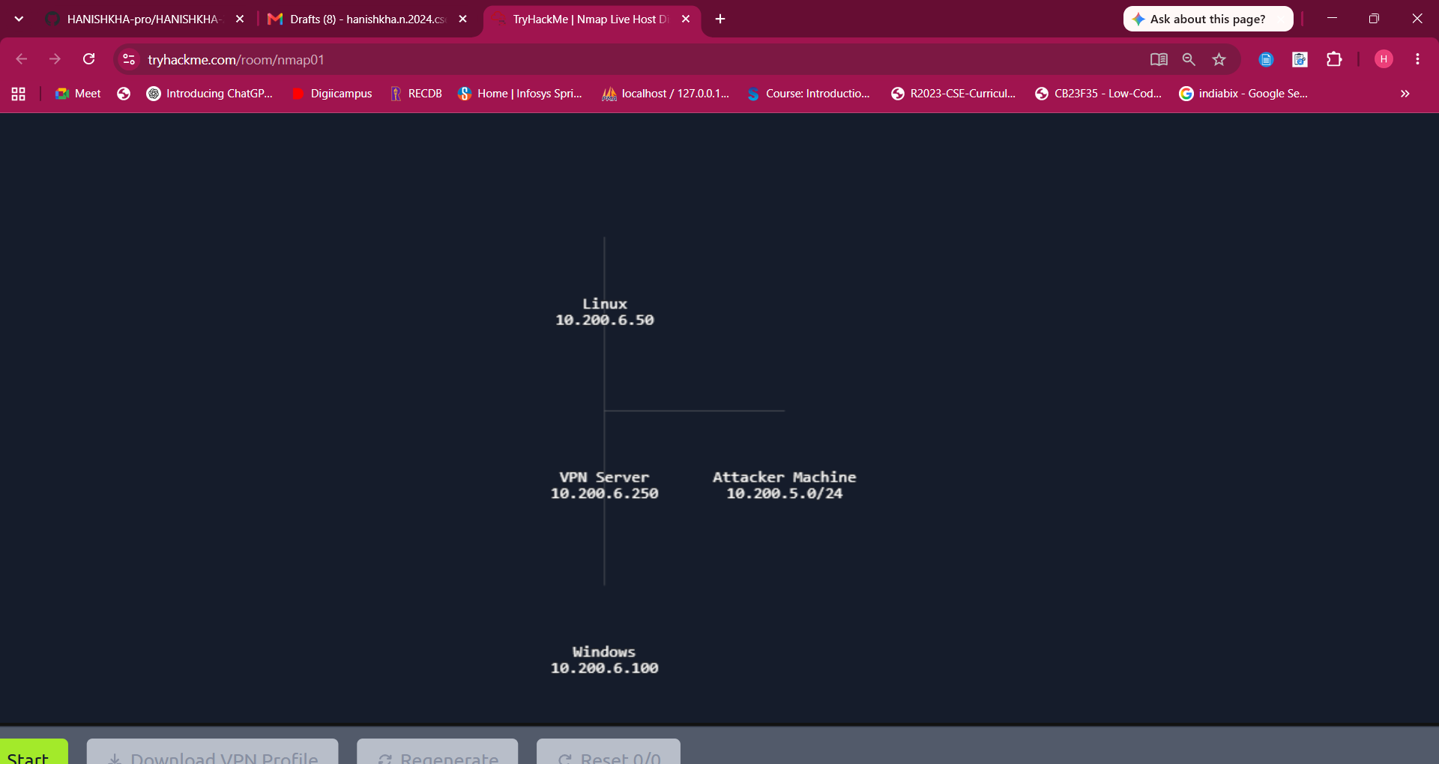
RESULT:


